English has a pre-eminent place in education and in society. A high-quality education in English will teach pupils to speak and write fluently so that they can communicate their ideas and emotions to others, and through their reading and listening, others can communicate with them. Through reading in particular, pupils have a chance to develop culturally, emotionally, intellectually, socially and spiritually. Literature, especially, plays a key role in such development. Reading also enables pupils both to acquire knowledge and to build on what they already know. All the skills of language are essential to participating fully as a member of society and we seek to ensure that all pupils learn to speak, read and write fluently and confidently.

Aims
The overarching aim for English in the national curriculum and in our school is to promote high standards of language and literacy by equipping pupils with a strong command of the spoken and written language, and to develop their love of literature through widespread reading for enjoyment. Our teaching of English aims to ensure that all pupils:
- Read easily, fluently and with good understanding
- Develop the habit of reading widely and often, for both pleasure and information
- Acquire a wide vocabulary, an understanding of grammar and knowledge of linguistic conventions for reading, writing and spoken language
- Appreciate our rich and varied literary heritage
- Write clearly, accurately and coherently, adapting their language and style in and for a range of contexts, purposes and audiences
- Use discussion in order to learn; they should be able to elaborate and explain clearly their understanding and ideas
- Are competent in the arts of speaking and listening, making formal presentations, demonstrating to others and participating in debate

Reading
The programmes of study for reading at key stages 1 and 2 consist of 2 dimensions:
- word reading
- comprehension (both listening and reading)
It is essential that teaching focuses on developing pupils’ competence in both dimensions; different kinds of teaching are needed for each.
Skilled word reading involves both the speedy working out of the pronunciation of unfamiliar printed words (decoding) and the speedy recognition of familiar printed words. Underpinning both is the understanding that the letters on the page represent the sounds in spoken words. This is why phonics should be emphasised in the early teaching of reading to beginners (ie unskilled readers) when they start school.

Good comprehension draws from linguistic knowledge (in particular of vocabulary and grammar) and on knowledge of the world. Comprehension skills develop through pupils’ experience of high-quality discussion with the teacher, as well as from reading and discussing a range of stories, poems and non-fiction.
All pupils must be encouraged to read widely across both fiction and non-fiction to develop their knowledge of themselves and the world they live in, to establish an appreciation and love of reading, and to gain knowledge across the curriculum. Reading widely and often increases pupils’ vocabulary because they encounter words they would rarely hear or use in everyday speech. Reading also feeds pupils’ imagination and opens up a treasure house of wonder and joy for curious young minds.
It is essential that, by the end of their primary education, all pupils are able to read fluently, and with confidence, in any subject in their forthcoming secondary education.

- At Cotford St Luke Primary School Guided Reading takes place in Year 2 upwards. In Reception and Year 1 they will be focusing on the children’s Phonics Skills but will complete daily Shared Reading with the children where they will discuss what they are reading.

- Guided Reading takes place as a whole class session across the school. However, this is supplemented with smaller group sessions where appropriate.
- A session should last approximately thirty to 45 minutes.
- Tasks are differentiated to meet the children’s needs.
- At Cotford St Luke Primary School we use VIPERS to teach our Guided Reading skills.

In Year 2 the format is as follows:

Session 1 | Read the text. Discuss any words that aren’t understood.
Session 2 | Discuss questions verbally.
Session 3 | Answer questions independently.

As the year progresses the children will have more independent opportunity to answer VIPERS Questions.

In LKS2 the format of the week is:
Session 1 | Vocabulary focus- read through the text, discuss any unknown vocabulary.
Session 2 | The children will complete the Focus Questions around one of the VIPERS skills.
Session 3 | The children will complete the questions based on the other VIPERS skills.

In UKS2 the format of the week is:
Session 1 | Focus on Vocabulary. They will read the text through and discuss vocabulary. They will also use the dictionary to explore the meaning of the words and may explore synonyms and antonyms of the words also.
Session 2 | The children will complete the Focus Questions around one of the VIPERS skills.
Session 3 | The children will complete the questions based on the other VIPERS skills.

Phonics and Spelling

For Phonics please refer to our separate Phonics Policy.

Learning spelling rules in Key Stage Two
In Cotford St Luke Primary School, we use the basis of Westover Green to provide a clearly planned progression through all the requirements of the National Curriculum. Spelling takes place 4 times a week in KS2 as an adult led session. It is also closely monitored in the children’s work.

Writing

The programmes of study for writing at key stages 1 and 2 are constructed similarly to those for reading:
- Transcription: spelling (see above) and handwriting
- Composition (articulating ideas and structuring them in speech and writing)
It is essential that teaching develops pupils’ competence in these 2 dimensions. In addition, pupils should be taught how to plan, revise and evaluate their writing. These aspects of writing have been incorporated into the programmes of study for composition.
Writing down ideas fluently depends on effective transcription: that is, on spelling quickly and accurately through knowing the relationship between sounds and letters (phonics) and understanding the morphology (word structure) and orthography (spelling structure) of words. Effective composition involves articulating and communicating ideas, and then organising them coherently for a reader. This requires clarity, awareness of the audience, purpose and context, and an increasingly wide knowledge of vocabulary and grammar. Writing also depends on fluent, legible and, eventually, speedy handwriting.

Handwriting Aim

- To know the importance of clear and neat presentation in order to communicate meaning effectively.
- To write legibly in both joined and printed styles with increasing fluency and speed by:
  - Having a correct pencil grip;
  - Forming all letters correctly;
  - Knowing the size and orientation of letters.

Teaching Time

In reception handwriting is taught through Monster Phonics sessions which happen on a daily basis. Handwriting is then something that is done as part of their daily writing session where staff will pick up on errors in formation. In other year groups handwriting should be taught as part of their English lesson and topic lessons. In Key Stage One this is continued through the use of the Monster Phonics Scheme. Those who are ready to will start to learn joins in Year 2 before moving into KS2. In KS2 it is expected that children will use joins and a cursive script. Children who find handwriting difficult should be targeted for daily intervention.

Handwriting Implements

- Reception - Variety of suitable implements e.g. pencils, crayons, large felt pens.
- Year 1and 2 - pencils only.
- In Years 3, 4 and 5 - The children will be writing in pencil only but with a cursive script.
- Year 6 – Children will start the year writing in pencil. Once the teaching staff feel the child’s writing is to a high standard they will be offered a pen to use. The children can then choose whether to write in pencil or pen. No ink in Maths books.

Teachers/Support staff/Parents

All the adults working in school should model good handwriting for the children. All adult helpers should aim to produce quality writing at all times – on the whiteboard and for marking. This should match the style and stage of development of the year group. All adults should use the school script when writing in the children’s books so that the models offered to the children are consistent.

Inclusion
Some pupils that need more support with their handwriting will need a specific or group intervention programme that will be drawn up in consultation with the SEN coordinator. The SENCO has resources for those who have difficulties. Thicker triangular pencils, pencil grips and wider lines will be used by children experiencing problems writing, alongside other activities to develop their fine motor skills. Children with motor control difficulties will have specific timetabled interventions.

Writing Composition

At Cotford St Luke Primary School, the teaching of writing is carefully planned to ensure that children:

- Are enthused by, and highly capable of, organising and expressing their thoughts.
- Are able to do this through writing clearly, accurately and coherently, adapting their language and style in and for a range of contexts, purposes and audiences.

The writing content from the National Curriculum is taught in units, with pupils applying their knowledge to writing with a purpose across a range of subjects. Pupils record and consolidate their understanding in their English books. It is expected that these books will show evidence of daily writing including:
Handwriting, spelling and new learning of objectives. There will also be evidence of a draft of their end of unit write with editing taking place. The children then use their author books to present their neat copy of their end of unit write.

Presentation, Editing, Marking and Reviewing

At Cotford St Luke Primary School we take great pride in the presentation of our books and there are clear expectations on both the staff and the pupils for them.

Non-negotiables
- All books should have an underlined long date and I can statement. In KS1 this may be typed and then stuck in by the child.
- All children should underline and write sub- headings.
- Learning Objective should be written for every piece of work.
- Positive comment and next step is necessary either given verbally or written.
- Indication of whether child completed task I, P or S.
- In Foundation Stage, children should be given verbal positive feedback after each task.
- It is expected that only work is evident in the children’s book. Doodling or other unasked for drawings are not acceptable. We expect that the children take care over their work.
An in-depth mark will take place when children have completed an end of unit write which will then feed into the planning of the editing stage.

Editing Process
We have an editing structure in place here at Cotford St Luke Primary School and all teachers should allow 2-3 lessons for this process to be completed.
In Year 1:
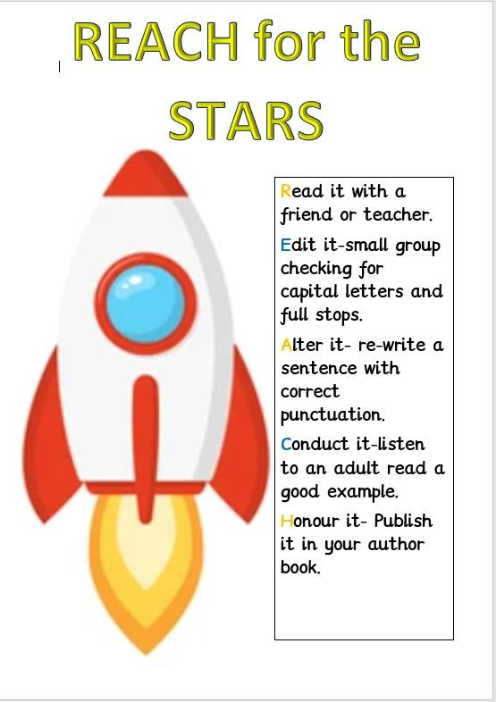

In Year 2:
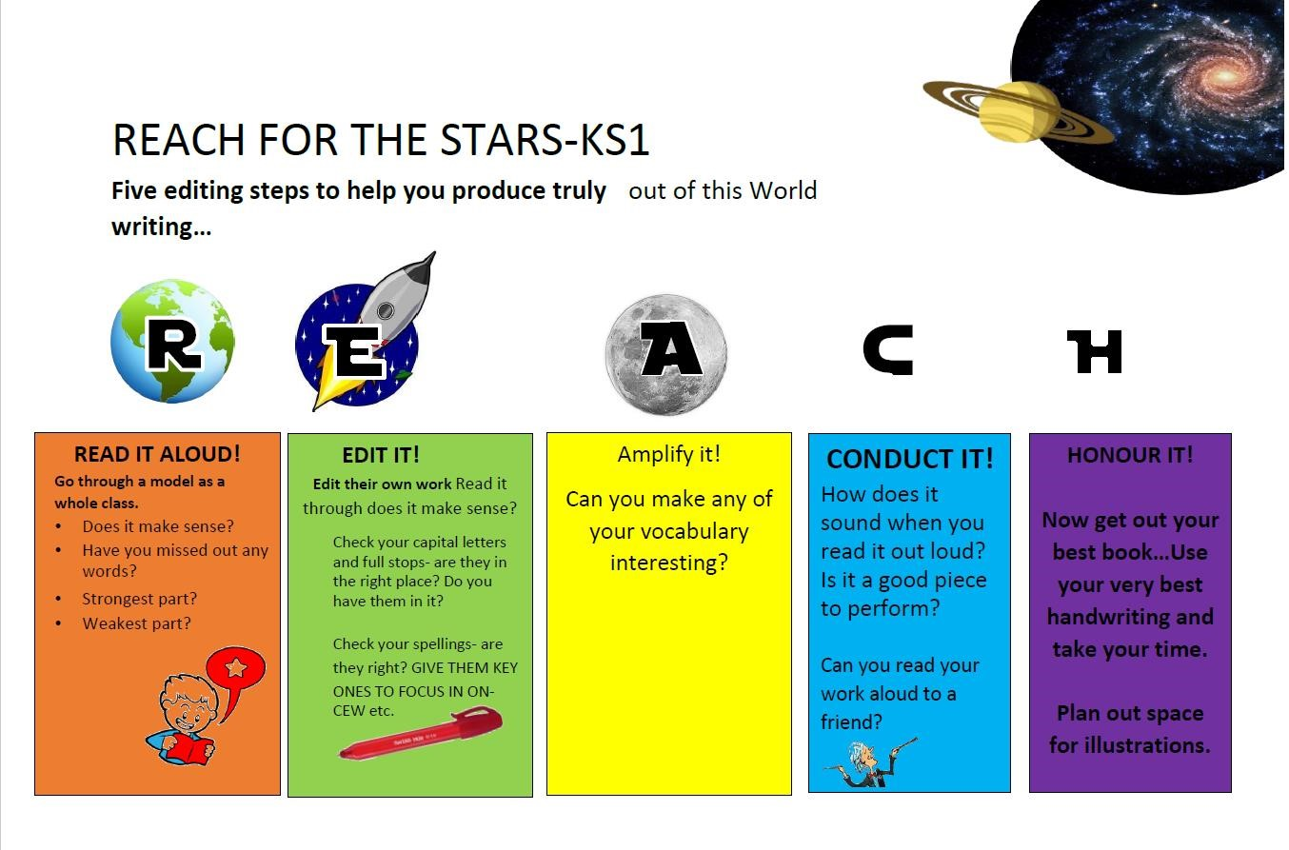

In KS2:
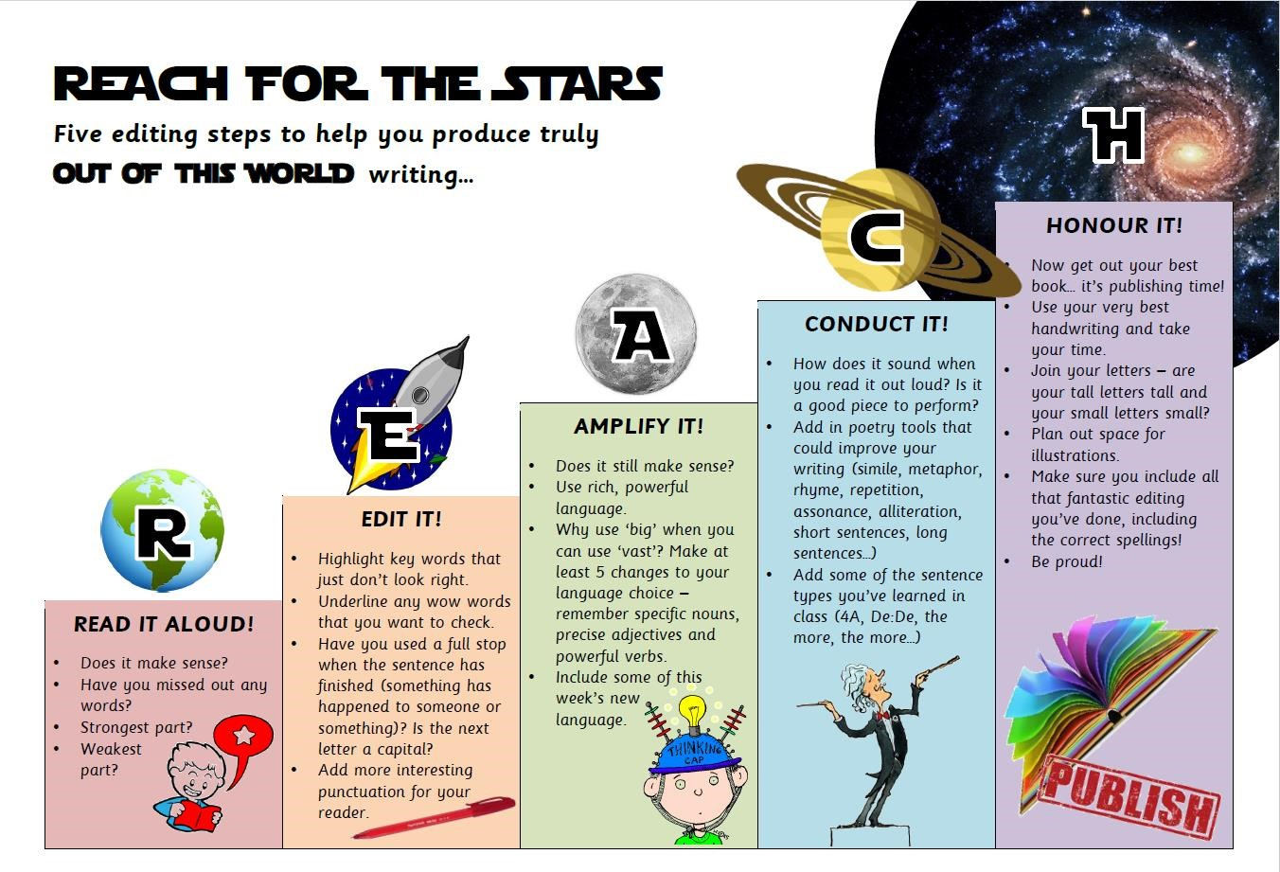

As the children move up through the school they will be expected to become more independent in their editing skills and will need minimum adult led sessions to complete this process.

