


Cotford St L
u
ke
P
rimary School

Phonics Policy

This policy contains the aims and working practice for Phonics at
Cotford St Luke Primary School

Phonics Lead teacher:

Rebecca Hill

Date:

July 2025

Policy to be reviewed:

July 202
6

Introduction

At Cotford St Luke Primary School, we believe that early, effective phonics teaching and learning is essential for achieving high attainment in reading and writing. Additionally, children’s confidence with phonics is integral to the curriculum and is used in all subjects. Phonics is the process of teaching children to correlate an individual sound with its corresponding letter or letter group. The more easily they can hear, identify, and manipulate sounds, the easier it will be for them to decode new words when they are ready to read. Achievement in this area benefits every area of pupils’ development and the school as a whole.
This policy is aimed at reinforcing a consistent, high quality approach to the teaching of phonics across the Early Years Foundation Stage (EYFS), Key Stage One and on into Key Stage Two for children who require further support.

Aims

- To teach children oral discrimination, phonemic awareness, alliteration and rhyme to aid reading, writing and spelling development.
- To encourage the use of segmenting and blending so that decoding skills provide a sound foundation for reading, writing and spelling.
- To ensure that the teaching of phonics is lively, interactive and inclusive.
- To enable children to use their phonological awareness across the curriculum.
- To ensure that children know the 44 phonemes within the English language.
- To teach children to recognise the graphemes within words and associate them with the appropriate phoneme when reading.
- To provide children with strategies to identify and decode Common Exception and High Frequency words.

Objectives
- To provide consistent, high quality phonics teaching that ensures all children have a strong foundation upon which to tackle the complexity of reading and writing.
- To ensure that teaching of synthetic phonics is systematic and progressive throughout the Foundation stage, Key Stage One and Key Stage Two for those children needing interventions to support phonemic knowledge and understanding.
- To ensure that children have a sound phonetic knowledge, understanding and skills so that they can decode words with confidence and engage with higher order reading and writing skills.


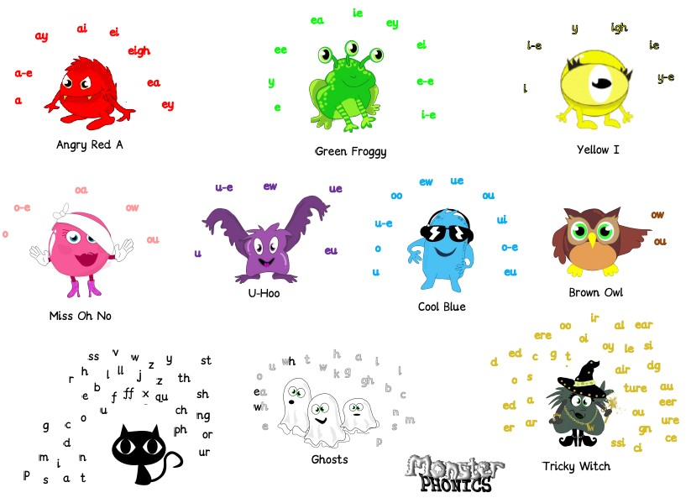

Teaching and Learning

At
Cotford St Luke Primary School

we use DFE listed, Monster P
honics as a
whole
-
class scheme. ‘Monster Phonics’ is a rigorous, systematic synthetic
programme developed by Ingrid Connors, a primary teacher, phonics
specialist and audiological scientist. All of the resources within the programme
are mapped against the
Letters and Sounds phases 1

to 6

and the
KS1 Spelling
Curriculum
.

Different to any other scheme, Monster Phonics uses colour to consistently
code for key graphemes in English. Colour shows children how to pronounce
the most difficult aspects of reading.
It is unique in that it uses character
(
monster) phoneme cues and colour coding to represent the long vowel
sounds, silent letters and tricky letters. With Monster Phonics, spellings are more
memorable and learning to read and spell becomes exciting and fu
n!


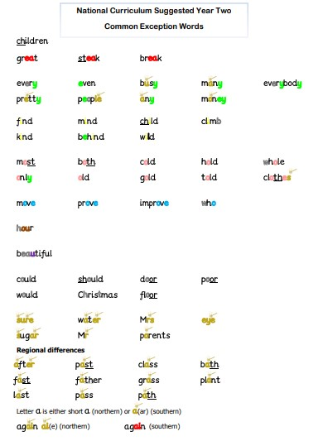

The innovative c
olour
-
coding system aims to
accelerate

learning to read and
spell. It is the only scheme that uses colour

coding for sound and audio
-
visual
cues (monsters) to
bring phonics teaching to life.
Visual learners benefit from
the visual memory of colour in words. EAL learners have pronunciation support
for every word that they learn. Monster Phonics highlights the existence of the
open syllable spelling of long vowels A, E, I, O and U, such as in be
, no, apron,
open, me which many young learners misspell.

Example

of Yr 2 Common exception wo
rds

Phonics in Nursery

Children at our Nursery start phonics right from the point of entry. Teaching and learning is covered using Phase 1 of Letters and Sounds.
Phase 1 concentrates on developing children's speaking and listening skills and lays the foundations for the phonic work which starts in Phase 2. The emphasis during Phase 1 is to get children attuned to the sounds around them and ready to begin developing oral blending and segmenting skills.
Phase 1 is split into seven aspects. Each aspect contains three strands: Tuning in to sounds (Auditory Discrimination), Listening and remembering sounds (Auditory Memory and Sequencing) and Talking about Sounds (developing vocabulary and language comprehension).
It is intended that each of the first six aspects should be dipped into, rather than going through them in any order, with a balance of activities. Aspect 7 will usually come later, when children have had plenty of opportunity to develop their sound discrimination skills.

Aspect 1 - General sound discrimination - environmental

The aim of this aspect is to raise children's awareness of the sounds around them and to develop their listening skills. Activities suggested in the guidance include going on a listening walk, drumming on different items outside and comparing the sounds, playing a sounds lotto game and making shakers.

Aspect 2 - General sound discrimination - instrumental sounds
This aspect aims to develop children's awareness of sounds made by various instruments and noise makers. Activities include comparing and matching sound makers, playing instruments alongside a story and making loud and quiet sounds.

Aspect 3 - General sound discrimination - body percussion
The aim of this aspect is to develop children's awareness of sounds and rhythms. Activities include singing songs and action rhymes, listening to music and developing a sounds vocabulary.

Aspect 4 - Rhythm and rhyme
This aspect aims to develop children's appreciation and experiences of rhythm and rhyme in speech. Activities include rhyming stories, rhyming bingo, clapping out the syllables in words and odd one out.



Aspect

5

-

Alliteration

The focus is on initial sounds of words, with activities including I
-
Spy type games
and matching objects which begin with the same sound.

Aspect

6

-

Voice

sounds

The aim is to distinguis
h between different vocal sounds and to begin oral
blending and segmenting. Activities include Metal Mike, where children feed
pictures of objects into a toy robot's mouth and the teacher sounds out the
name of the object in a robot voice
-

/c/
-
/u/
-
/p/ cup
, with the children joining
in.

Aspect 7
-

Oral blending and segmenting

In this aspect, the main aim is to develop oral blending and segmenting skills.

To practise oral blending, the teacher could say some sounds, such as /c/
-
/u/
-
/p/ and see whether the ch
ildren can pick out a cup from a group of objects.
For segmenting practise, the teacher could hold up an object such as a sock
and ask the children which sounds they can hear in the word sock.

The activities introduced in Phase 1 are intended to continue t
hroughout the
following phases, as lots of practice is needed before children will become
confident in their phonic knowledge and skills.

Once the staff within Nursery feel that the children are ready they begin to use
SATPIN to orally blend and segment w
ords before moving on to visually
blending and segmenting to read VC and CVC words.

Phonics lessons at
Cotford St Luke Primary School

use the following sequence
in all lessons:

Revise and Revisit

Teach

Practise

Apply

E
ach phonic lesson starts with a complete revisit of all the sounds that the
children have been taught so far.
In the Early Year Foundation stage, this is
achieved by using a fast
-
paced flashcard review. In Key Stage 1 this is
achieved using a Monster Phoni
cs
learning wall/chart to review all the sounds
that have been previously taught since EYFS up to a current point.

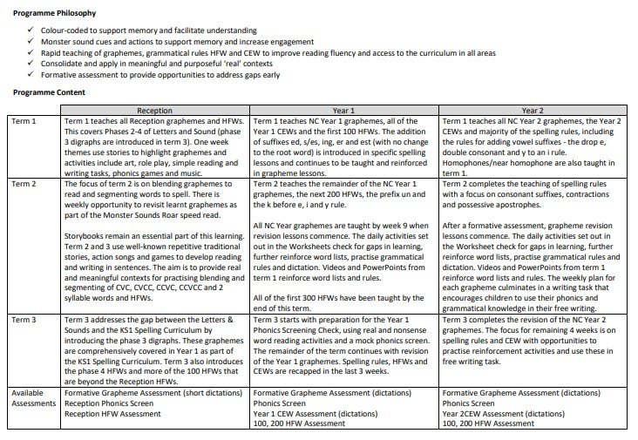



Assessment

Assessment within each year groups takes place each half term in line with our
school’s half termly data points. Assessment in each year groups differs slightly.

EYFS
-

Half termly assessment checks:

Grapheme/ Phoneme Correspondence (GPC), High Frequency Word
recognition and ability to blend and segment.

Summer 2
-

All reception pup
ils

are assessed using the first 20 words from past
Phonic Screening Papers. This is in preparation and planning for transition to
Year1.

Year 1

& Year 2

Resit children
-

These
pupils are assessed using Past P
honic
screening papers. Assessments are carried

out by their class teacher and a
selection are done by the phonics lead and SLT for quality assurance purposes.

Target children (bottom 20%) from the cohort are assessed using addition
assessments from Monster Phonics.

Year 2

(
not re
-
sits) and Key Stage 2 Target children
-

Pupils

are
assessed using
formative grapheme assessments (dictations) and using the Year 2 CEW
Assessment (dictations)

Information

from

all of our assessments feed back into Teaching and learning
so that gap
s are identified and robustly addressed through additional
intervention and targeted support within the classroom.


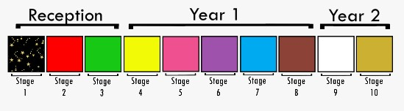
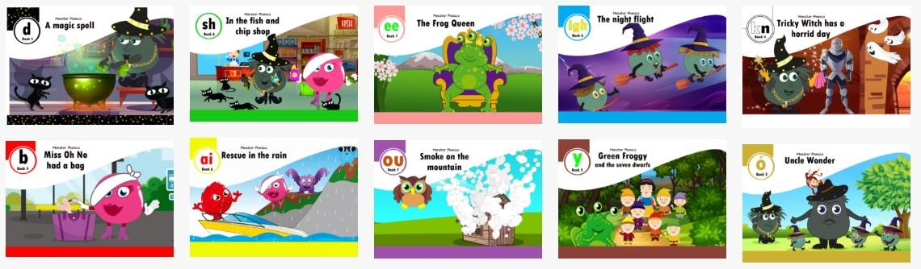
Reading Books

Our phonetically decodable

books are also fully matched

to the Monster
Phonics Programme
. Monster Phonics
books ensure that children are reading
using phonics that has been taught. Each book focuses on a key grapheme
and ability
-
appropriate high
-
frequency words
.

On a Monday half the class will receive a Monster Phonics book whilst the other
half will access th
e book via the e
-
books. This book will focus on sounds
covered in Phonics the previous week. On Wednesday the books will be
returned for the other half of the class to take home, and the rest will access
the e
-
book online.

Phonic keywords
and high
-
frequen
cy word practice boxes at the start of each
book help children to read the story with confidence. Stories include wow
words and centre around the popular monster characters. Each book ends
with questions to develop comprehension skills.

Intervention

If children need intervention or booster groups to reach age
-
related
expectations in phonics, this is provided in addition to the daily phonics session
so that as many children as possible can access their year group learning
objectives and reach age app
ropriate outcomes.
This will be a shorter session
than the lesson and will be a chance for children to review sounds they have
struggled with the same day with the aim to keep them on track.



Special Educational Needs and Disability

At
Cotford

St Luke Primary School

we
use
planning and

teaching flexibly in
order to ensure individual needs are met and children achieve their full
potential.

•

Differentiation through tasks to stretch and Challenge

•

Support using adults and additional resources.

By teaching in a whole class manner this allows flexibility for additional adults
to work with children who are either at risk of falling behind or extend those
who are moving forwards well. Children can be stretched and challenged
through using words cont
aining the sound/s learnt in sentences or noticing
patterns within the words. Those at risk of falling behind will be able to use
resources such as magnetic lessons and flashcards to ensure they can access
any activity be it written or practical.

Equal Opportunities

We are committed to providing a teaching environment conducive to
learning. All children are valued, respected and encouraged to take risks in
order to achieve regardless of ability, race, gender, religion, social
background, culture o
r disability.

Parent Partnership

At
Cotford St Luke Primary School

we strongly believe that positive partnerships
between staff and parents/carers are paramount in ensuring that children
achieve their full potential. With this in mind we:

•

Use online v
ideos to support the use of our weekly Sound books in
Reception.

•

Parent/carers are invited into school to an information meeting to
discuss how we teach phonics in school and to learn how they can
support their children at home.

•

Year 1 Parents/car
ers are

invited into school to
receive information
about the Phonic Screening Check as well learning how to support their
children are home.

•

We
send
home
phonetically
decodable
re
ading
books
for
parents/carers
to share with their child.

•

In addition to
regular Pa
rents Evening
s we stro
ngly encourage parents
to meet with teachers if they have any concerns about their child’s
learning.


Glossary of Terms

•

Segmenting
-

the ability to break up spoken words into their separate
sounds.

•

Blending
-

fluently joining
together the individual sounds.

•

D
ecoding
-

the ability to apply your knowledge of letter
-
sound
relationships, including knowledge of letter patterns, to correctly
pronounce written words.

•

P
honemes
-

the smallest unit of sound within a word.

•

G
raphemes
-

a way of writing down a phoneme.

•

B
ody percussion
-
the art of striking the body to produce various types of
sounds.

•

Alliteration
-

is when two or more words that start with the same sound
are used repeatedly in a phrase or a sentence.

