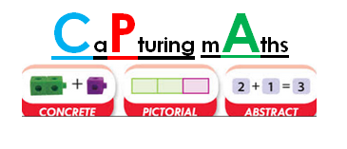
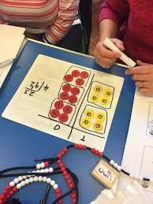


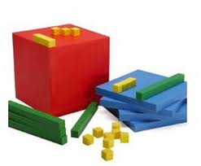Calculation Policy 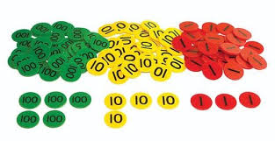

This policy has been designed to teach children to develop conceptual understanding through the progression of concrete, pictorial and abstract methods. This calculation policy should be used to support children to develop a deep understanding of number and calculation.

Background
This policy has been developed by CLP Maths Coordinators (Primary/Secondary).

Using the concrete-pictorial-abstract approach:
Children develop an understanding of a mathematical concept through the three steps (or representation) of concrete-pictorial-abstract approach. Reinforcement is achieved by going back and forth between these representations.
Concrete representation The enactive stage - a pupil is first introduced to an idea or a skill by acting it out with real objects. This is a 'hands on' component using real objects and it is the foundation for conceptual understanding.
Pictorial representation The iconic stage - a pupil has sufficiently understood the hands-on experiences performed and can now relate them to representations, such as a diagram or picture of the problem.
Abstract representation The symbolic stage - a pupil is now capable of representing problems by using mathematical notation, for example: 12 ÷ 2 = 6 .
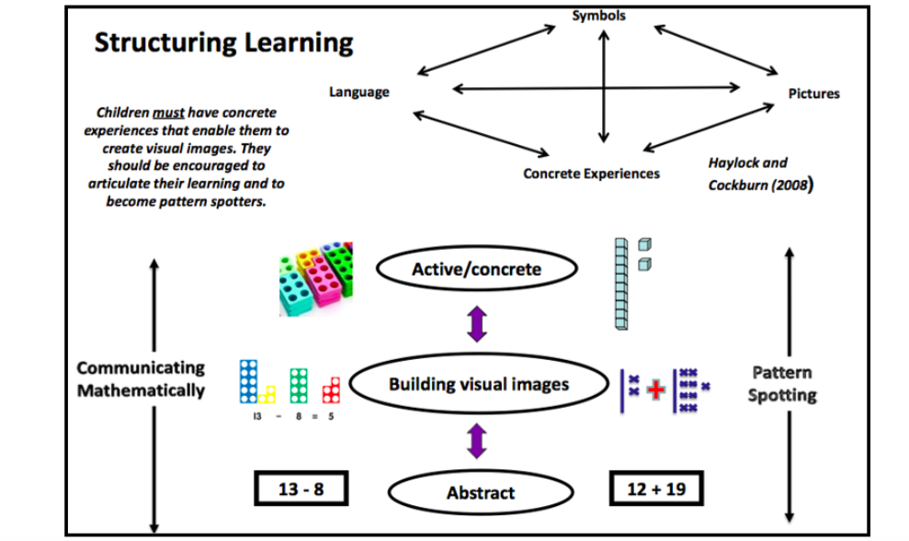
Part/Whole Model – Key Structures

Addition and Subtraction are connected. Add parts together to equal the whole, whole subtract part to name the missing part.
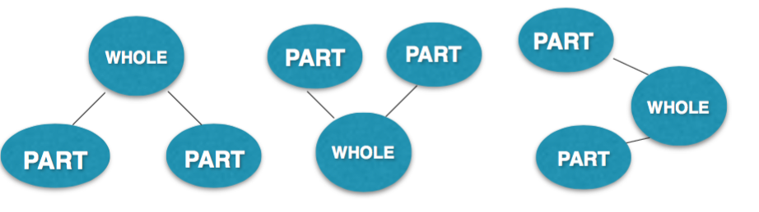
Guidance
This is document provides guidance and examples for key objectives for each year group but is not to be followed as a complete planning aid as not all objectives are exemplified.
Early Years
Developing Number Sense
Vocabulary
Part, whole, add, more, plus, and, make, altogether, total, equal to, equals, double, most, count on.
equal to, take, take away, less, minus, subtract, leaves, difference between, how many more, how many fewer / less than, most, least, count back , how many left, how much less is_?
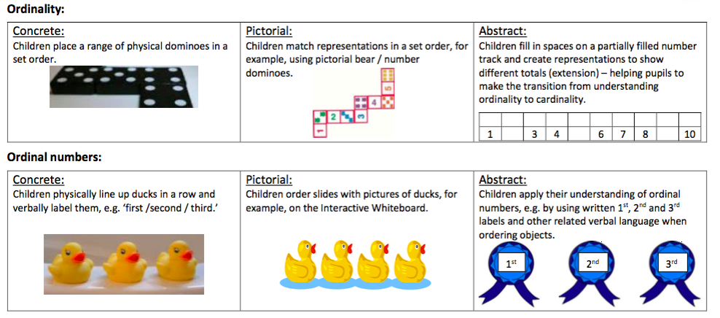
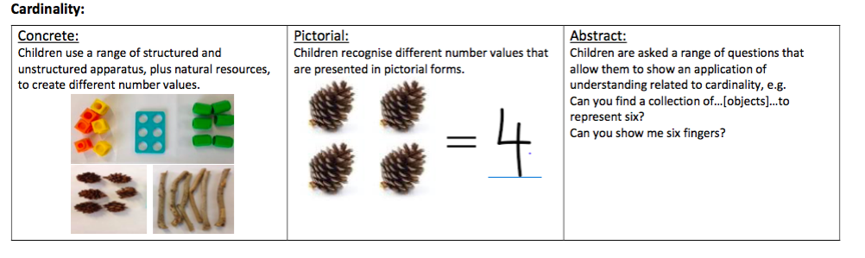
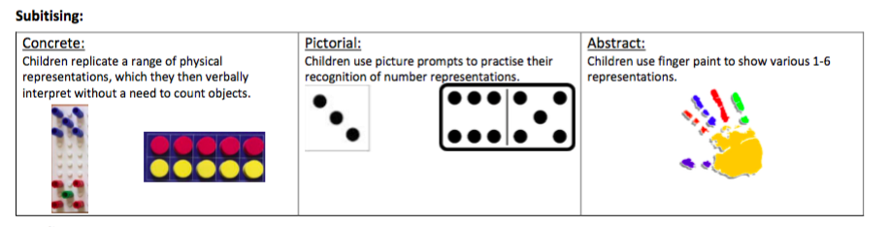

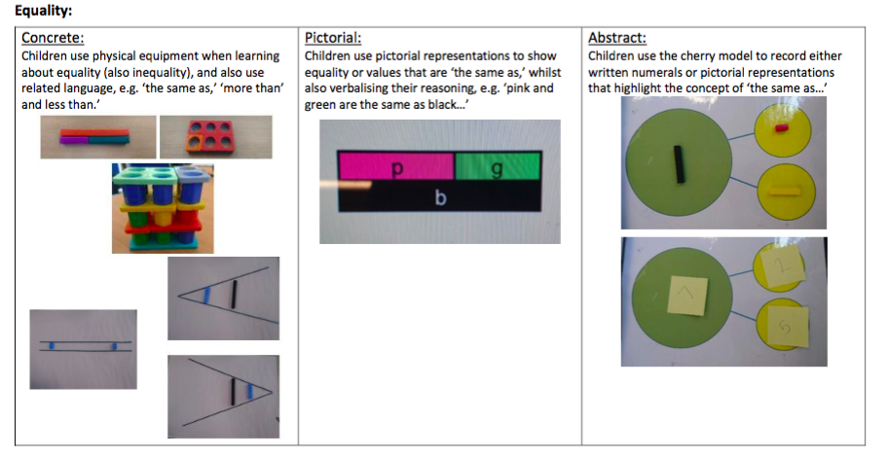
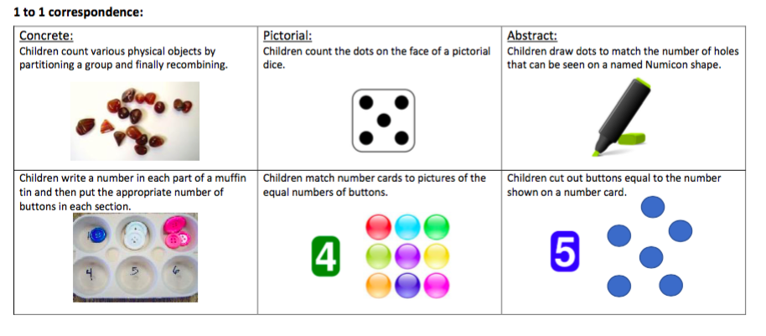
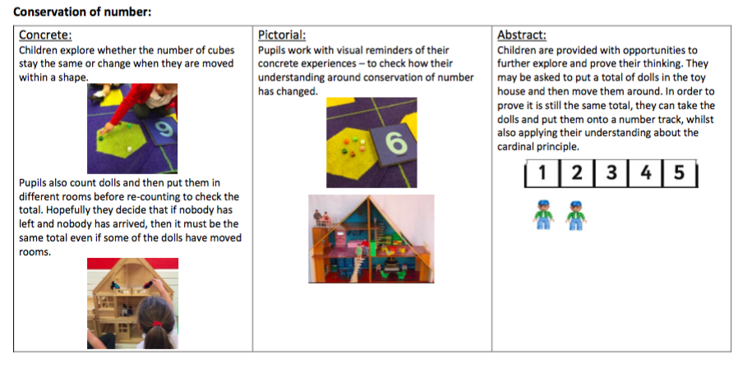
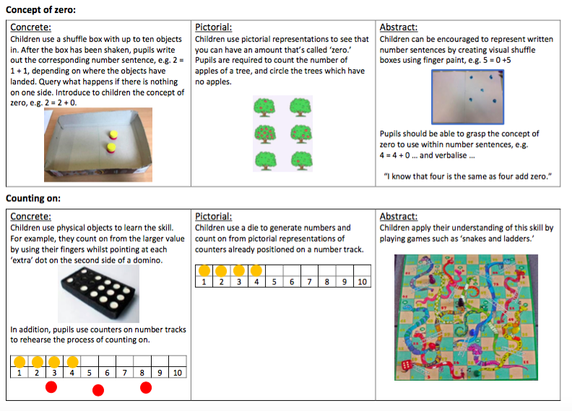

Reception
Addition
Vocabulary
Part, whole, add, more, plus, and, make, altogether, total, equal to, equals, double, most, count on.
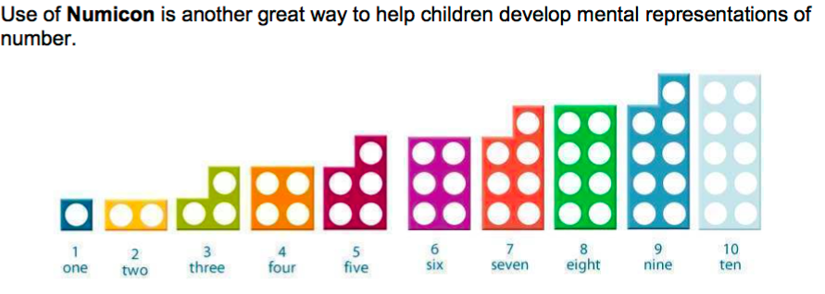
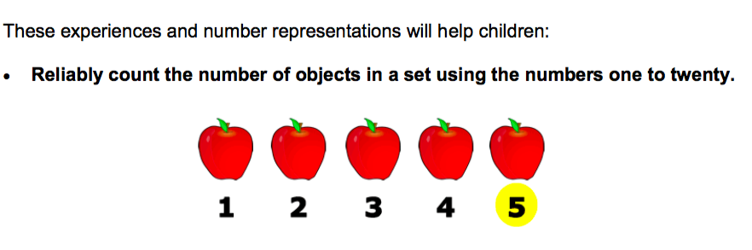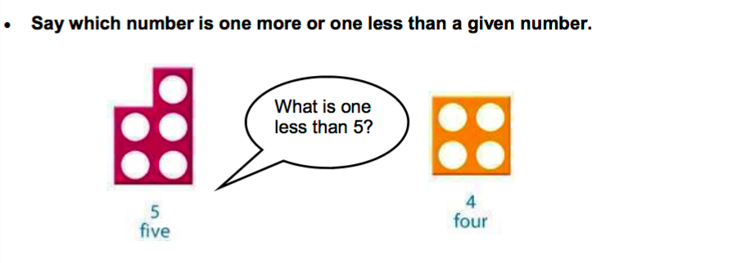

Explore part /whole relationship
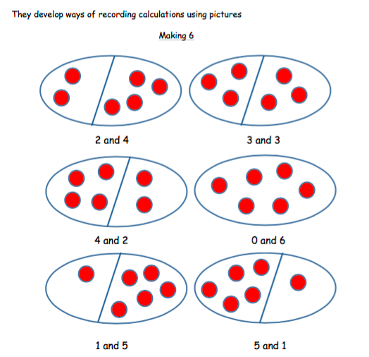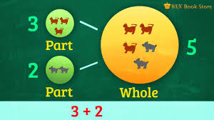
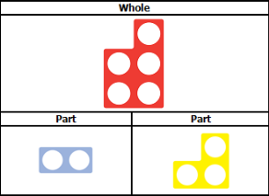
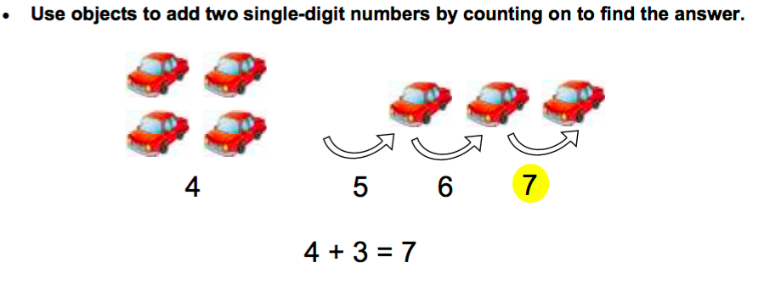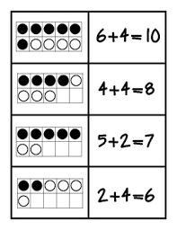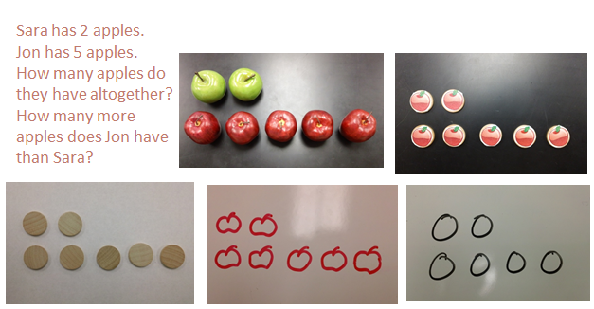
Solving problems using concrete and pictorial images.
Subtraction
Vocabulary
Part, whole, equal to, take, take away, less, minus, subtract, leaves, difference between, how many more, how many fewer / less than, most, least, count back , how many left, how much less is_?
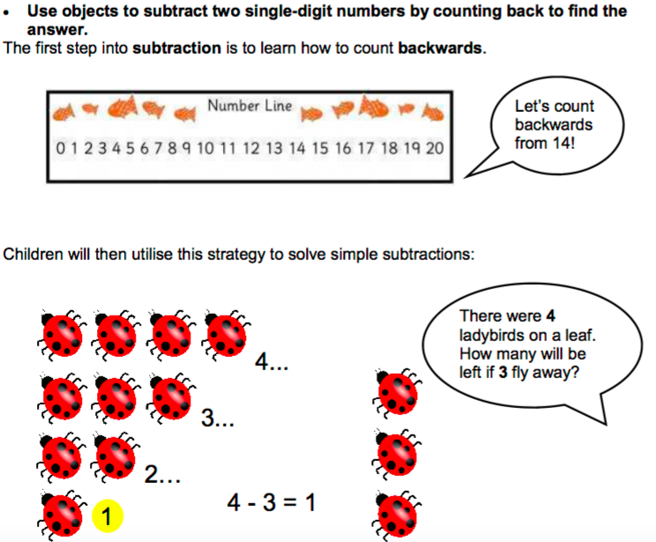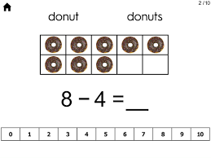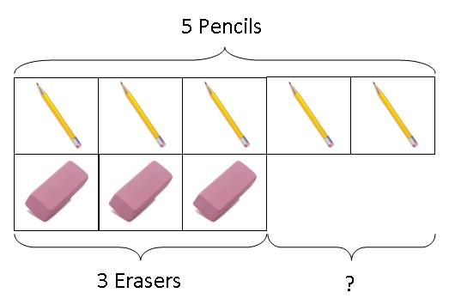
Solving problems using concrete and pictorial images.
Peter has 5 pencils and 3 erasers. How many more pencils than erasers does he have?
Multiplication
Vocabulary
Part, whole, groups of, lots of.
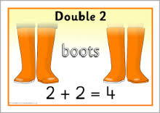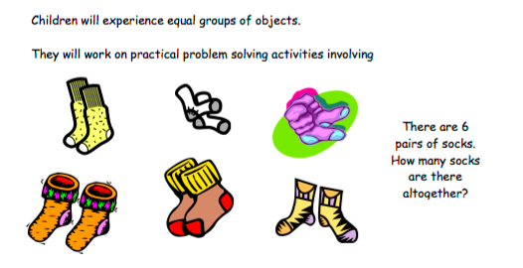
Division
Vocabulary
Part, whole, share, share equally, one each, two each…, group, groups of, lots of.
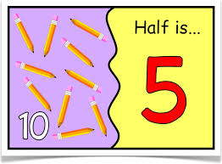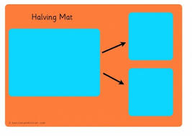
Year 1
Addition
Vocabulary
Part, whole, addition, add, forwards, put together, more than, total, altogether, distance between, difference between, equals = same as, most, pattern, odd, even, digit, counting on.
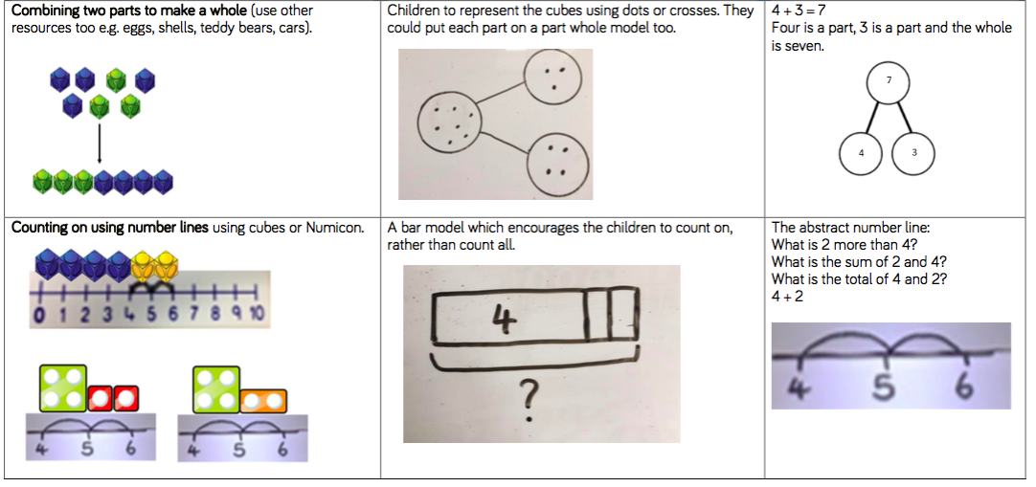
Learn number bonds to 20 and demonstrate related facts
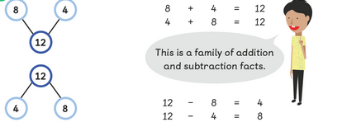
Teach addition and subtraction alongside each other as pupils need to see the relationship between the facts.
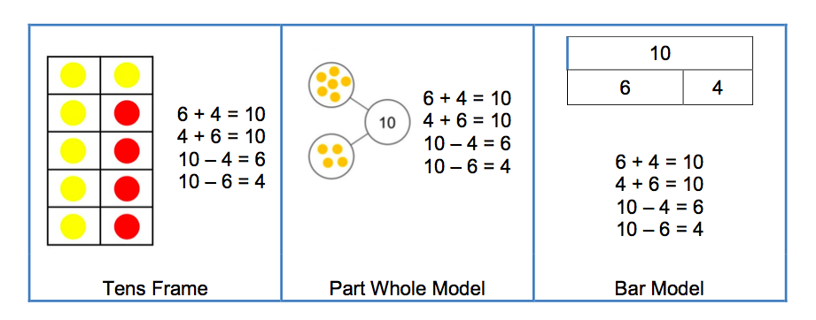
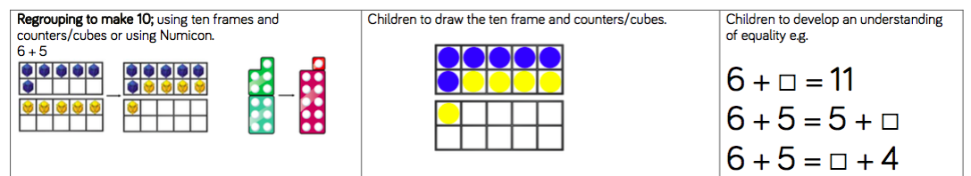
Subtraction
Vocabulary
Part, whole, subtraction, subtract, take away, distance between, difference between, more than, minus, less than, equals = same as, most, least, pattern, odd, even, digit,
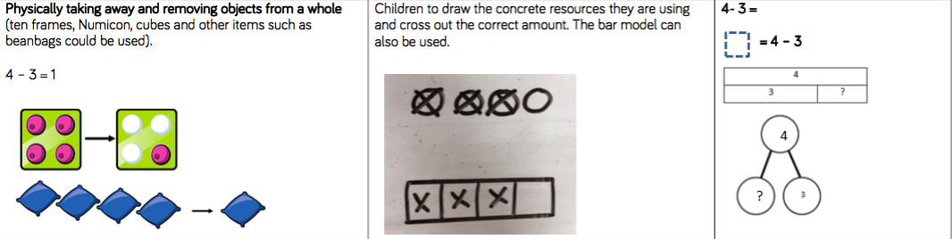
Subtraction by counting back

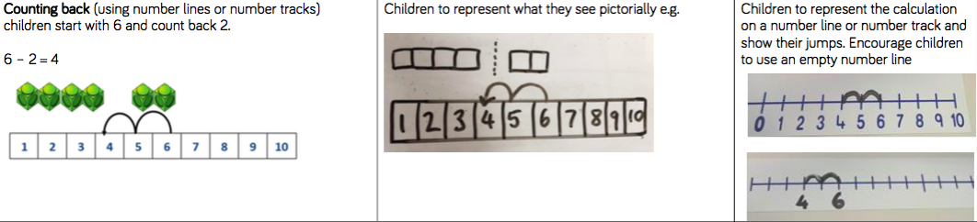
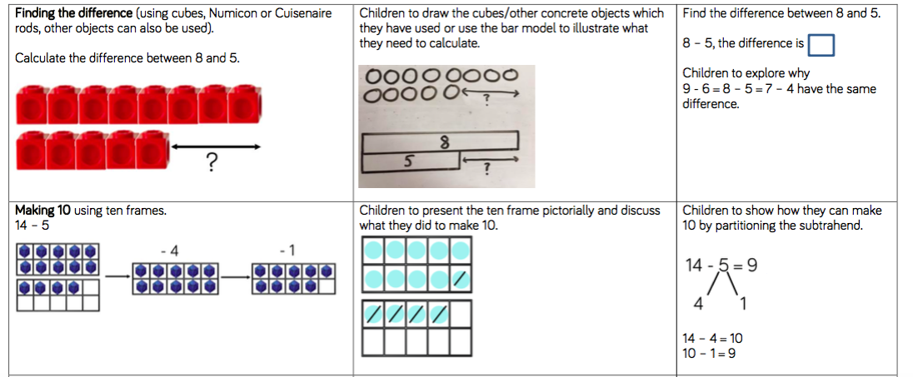

When subtracting using Dienes children should be taught to regroup a ten rod for 10 ones and then subtract from those ones
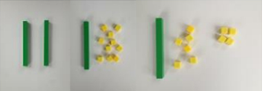
20 – 4 = 16

Subtracting multiples of 10
Using the vocabulary of 1 ten, 2 tens etc alongside 10, 20, 30 Is very important here as pupils need to understand that it is a 10 not a 1 that is being taken away
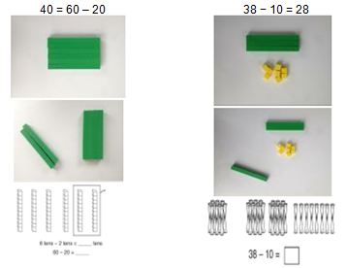

Multiplication
Vocabulary
Part, whole, ones, groups, lots of, doubling, repeated addition, groups of, lots of, times, columns, rows, longer, bigger, higher etc and times as (big, long, wide …etc)
Counting in multiples of 2, 5 and 10 from zero

Children should count the number of groups on their fingers as they are skip counting.
4 groups of 2 = 8
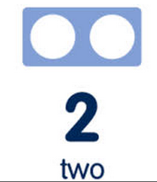
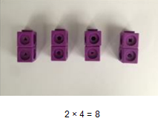
When moving to pictorial/written calculations the vocabulary is important
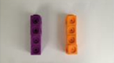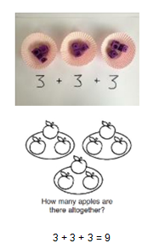
This image represents two groups of 4 or 4 twice Solving multiplication problems using repeated addition
Division
Vocabulary
Part, whole, share, share equally, one each, two each…, group, groups of, lots of, array
Pupils should be taught to divide through working practically and the sharing should be shown below the whole to familiarize children with the concept of the whole.
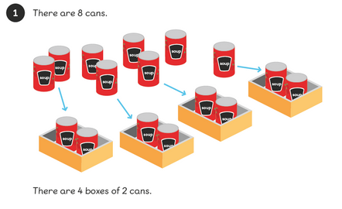
The language of whole and part part should be used.
8 ÷ 4 = 2

Year 2
Addition
Vocabulary
Part, whole, +, add, addition, more, plus, make, sum, total, altogether, how many more to make…? how many more is… than…? how much more is…? =, equals, sign, is the same as, tens, ones, partition
Near multiple of 10, tens boundary, more than, one more, two more… ten more…
Using concrete objects and pictorial representations to add 3 single digit numbers.
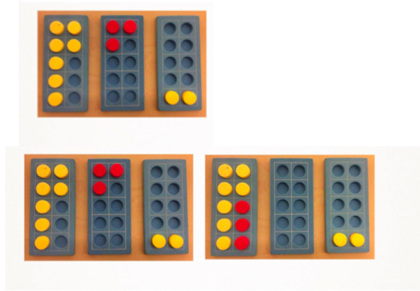 7+3+2 = leads to 10 + 2 =

Using concrete objects and pictorial representations to add a 2 digit number and ones and tens.
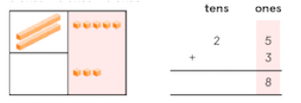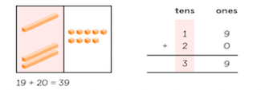
Using concrete objects and pictorial representations to add two 2-digit numbers
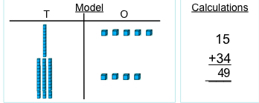

Leading to:
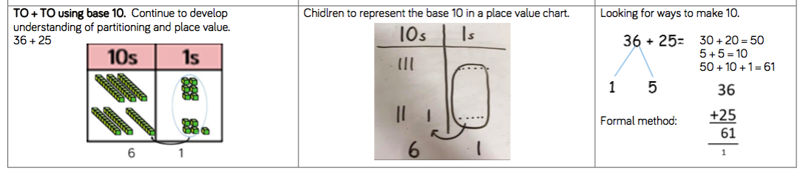
Using the bar to find missing digits.
It is important for children to use the bar in this way to encourage the use of it to aid with problem solving.
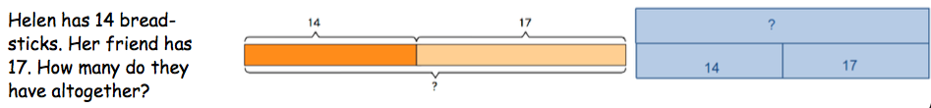
Subtraction
Vocabulary
Part, whole, Subtraction, subtract, take away, difference, difference between, minus
Tens, ones, partition
Near multiple of 10, tens boundary, Less than, one less, two less… ten less…
Using concrete objects and pictorial representations to subtract a 1-digit number from 2-digit number.
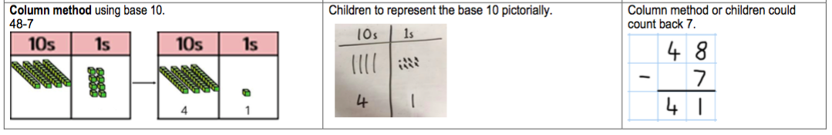
Using concrete objects and pictorial representations to subtract a 10s number from 2 digit number.
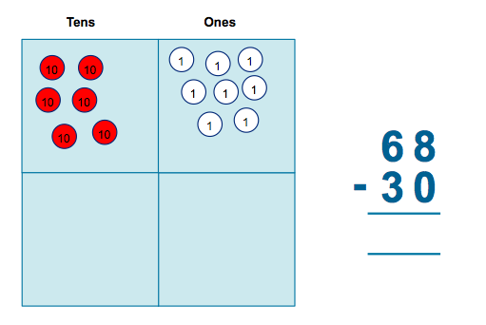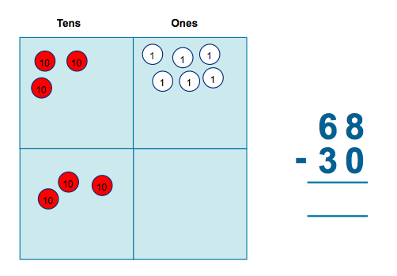

Using concrete objects and pictorial representations to subtract a 2-digit number from 2 digit number.
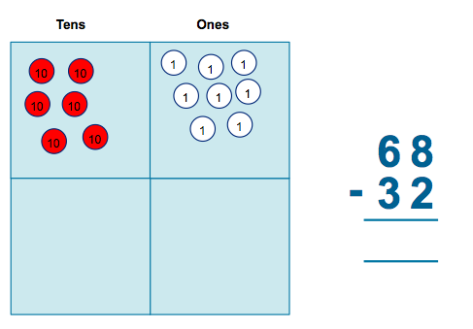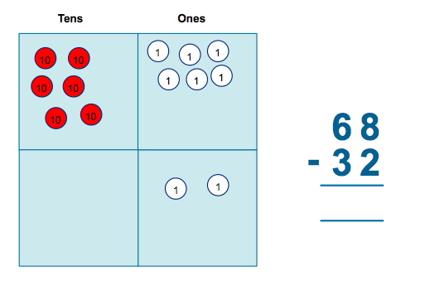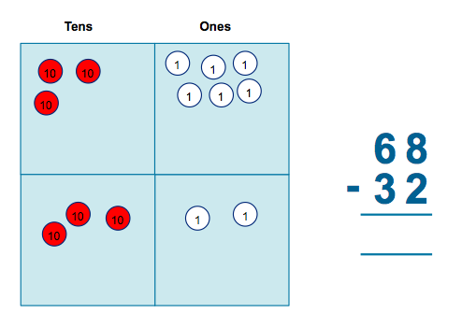
Greater Depth:
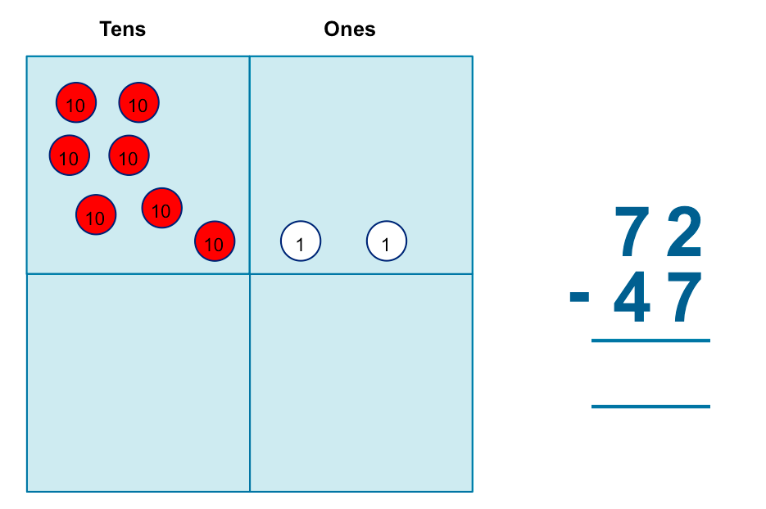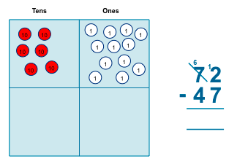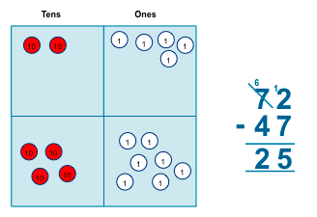

Recognise and use the inverse relationship between addition and subtraction

?
23 | 53
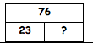 Use to check inverse calculations
Multiplication
Vocabulary
Part, whole, multiple, multiplication array, multiplication tables / facts, groups of, lots of, times, columns, rows
Skip counting in multiples of 2, 3, 5, 10 from 0
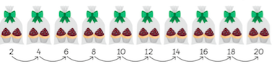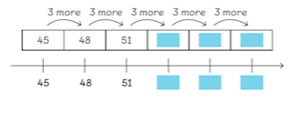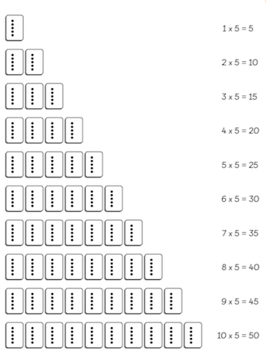
Recall and use multiplication facts for the multiplication tables 2, 5 and 10.
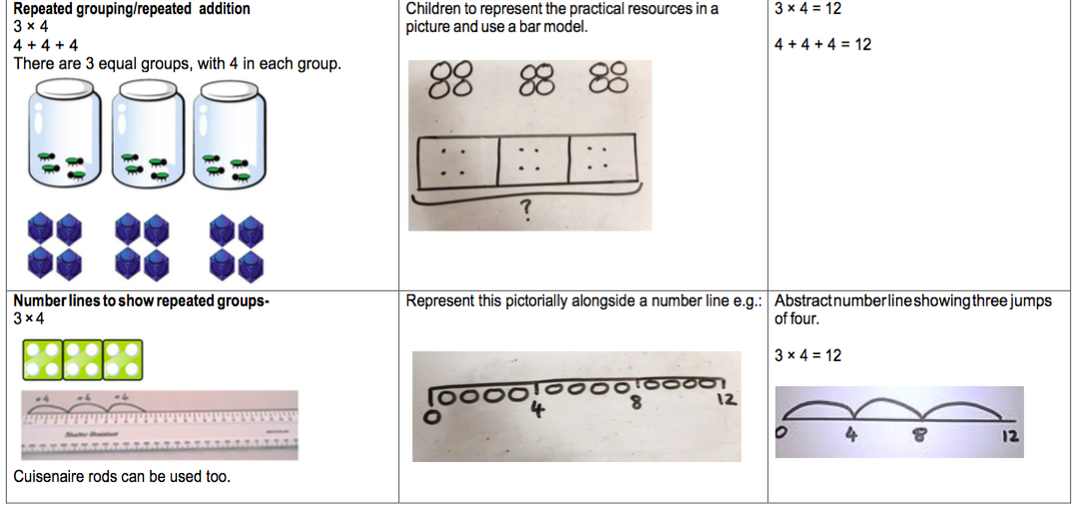
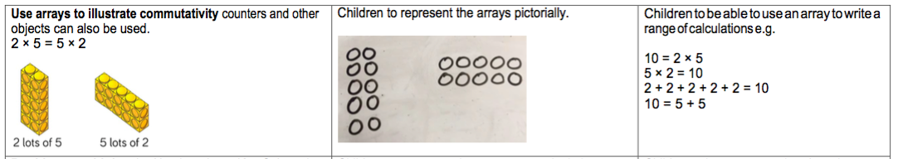
Division
Vocabulary
Part, whole, group in pairs, 3s … 10s etc, equal groups of, divide, ÷, divided by, divided into, remainder
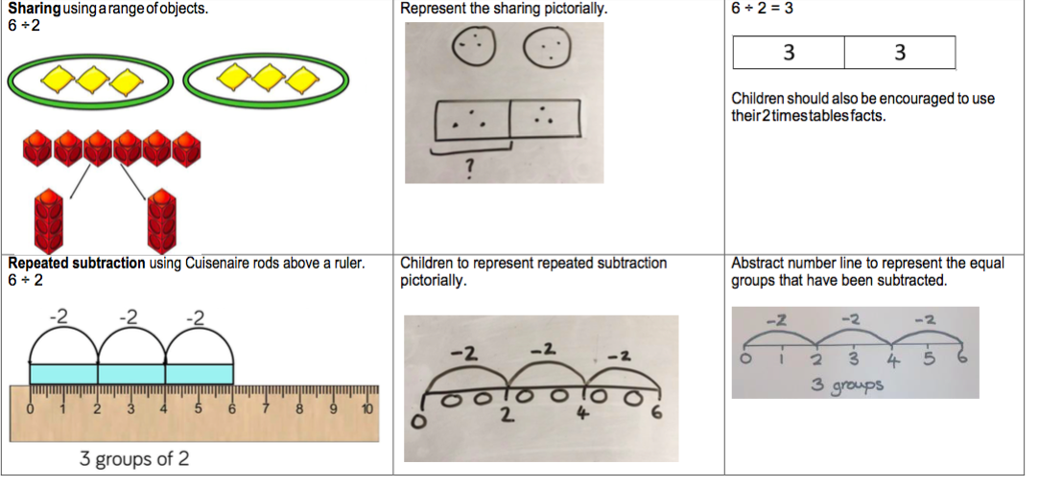
Solve division problems in context using arrays
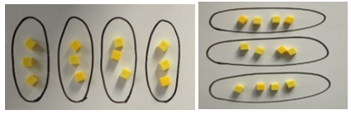
I can solve division as grouping.
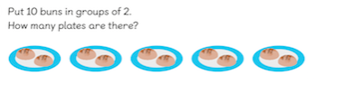
Greater Depth with remainders
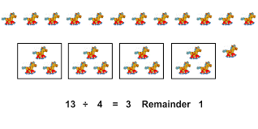
Year 3
Addition
Vocabulary
Part, whole, hundreds, tens, ones, estimate, partition, recombine, difference, decrease, near multiple of 10 and 100, inverse, rounding, column subtraction, exchange See also Y1 and Y2
Add two three-digit numbers.
Children need to use equipment first to support their understanding of place value.
Children to progress gradually to three digit + three digit starting without carrying and gradually moving towards carrying.
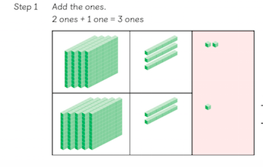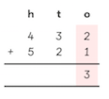
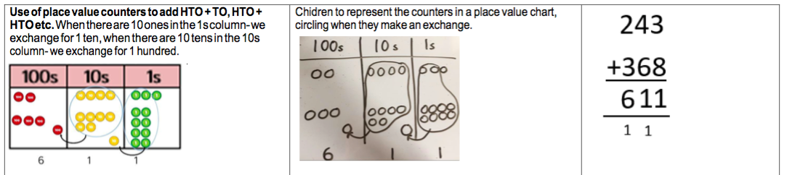
Using the bar to find missing digits.
It is important for children to use the bar in this way to encourage the use of it to aid with problem solving.

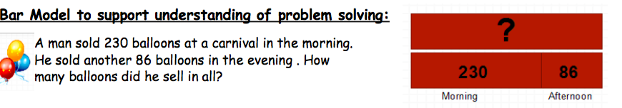
Subtraction
Vocabulary
Part, whole, hundreds, tens, ones, estimate, partition, recombine, difference, decrease, near multiple of 10 and 100, inverse, rounding, column subtraction, exchange See also Y1 and Y2
Subtract up to 3 digits from 3 digits.
Very important for children to use dienes equipment along with a place value chart to support.

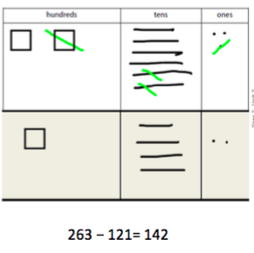

Only when secure with the method should exchanging be introduced.
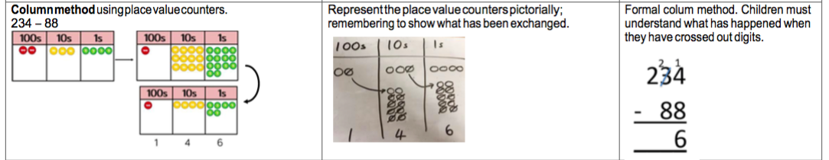

Using the bar to find missing digits.
It is important for children to use the bar in this way to encourage the use of it to aid with problem solving.
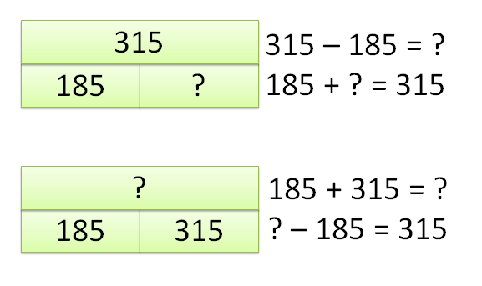
Multiplication
Vocabulary
Part, whole, multiple, partition, short multiplication and inverse
Children should be able to recall the 2, 5, 10, 3, 4 and 8 times tables.

Multiply a two-digit number by a one digit.
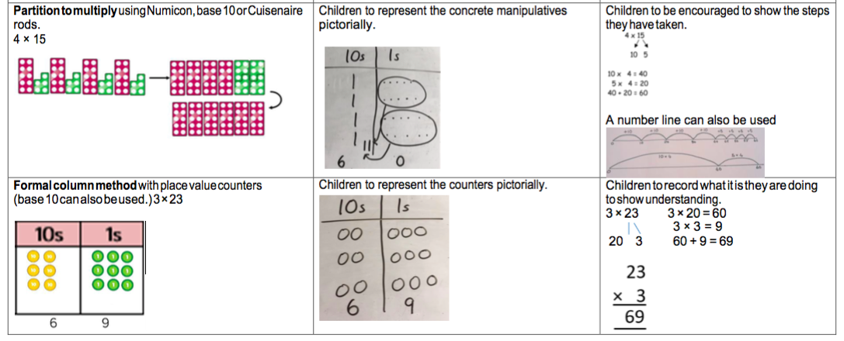
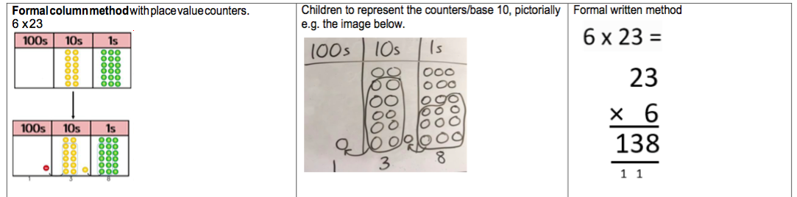

Using the bar to solve multiplication problems.
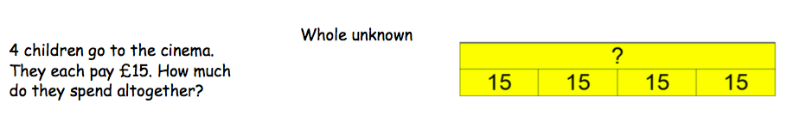
Division
Vocabulary
Part, whole, See Y1 and Y2 and Inverse, remainder
Dividing using short division.
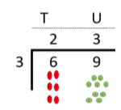
Remind children of correct place value, that 69 is equal to 60 and 9, but in short division, pose:
· How many 3’s in 6? = 2, and record it above the 6 tens.
· How many 3’s in 9? = 3, and record it above the 9 ones.

Once children demonstrate a full understanding of remainders, and also the short division method taught, they can be taught how to use the method when remainders occur within the calculation (e.g. 42÷3), and be taught to ‘carry’ the remainder onto the next digit.
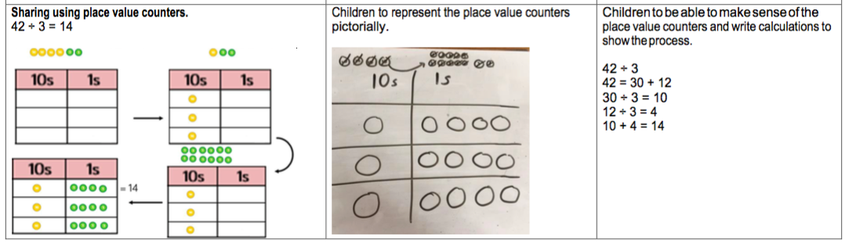
Using the bar to aid the solving of division problems – grouping and sharing
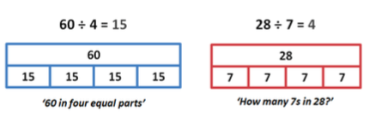

Year 4
Addition
Vocabulary
Part, whole, add, addition, sum, more, plus, increase, sum, total, altogether, double, near double, how many more to make..? how much more? ones boundary, tens boundary, hundreds boundary, thousands boundary, tenths boundary, hundredths boundary, inverse, how many more/fewer? Equals sign, is the same as.
Adding numbers with up to 4 digits.
Again this should start with the children using dienes to support them with lots of discussion about the value of each digit.
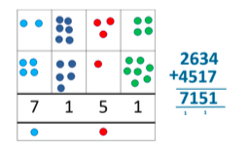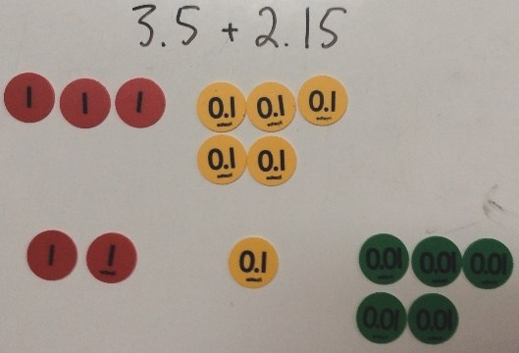
Using the bar to find missing digits.
It is important for children to use the bar in this way to encourage the use of it to aid with problem solving.
This is not a form of getting the correct answer but helping to guide children to the correct operation.
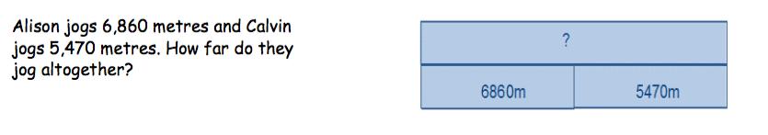
Subtraction
Vocabulary
Part, whole, subtract, takeaway, less, minus, decrease, fewer, difference, how many less to make..? how much less? ones boundary, tens boundary, hundreds boundary, thousands boundary, tenths boundary, hundredths boundary, inverse, how many fewer? Equals sign, is the same as.
To subtract with numbers up to four digits including exchanging when children are secure.
Children need to use place value counters to support their learning.
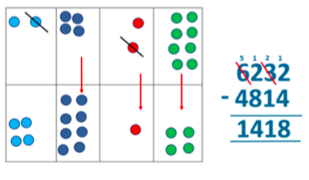
Using the bar to find missing digits.
It is important for children to use the bar in this way to encourage the use of it to aid with problem solving.
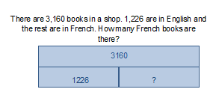

Multiplication
Vocabulary
Part, whole, Factor, product
Children to know all times tables to 12 x 12.
Children multiplying both two and three digits by a one digit number using place value counters.
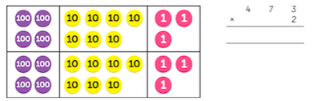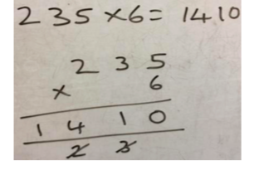
Multiplying using the bar.
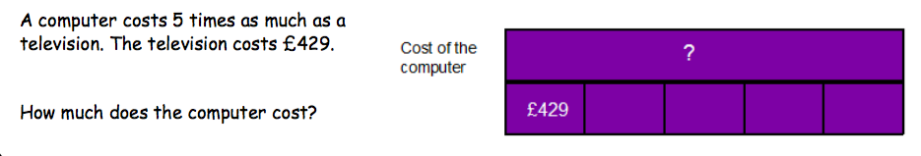
Division
Vocabulary
Part, whole, see years 1-3, divide, divided by, divisible by, divided into, share between, groups of
factor, factor pair, multiple, times as (big, long, wide …etc), equals, remainder, quotient, divisor and inverse
Dividing up to three digit numbers by a one digit number using short division.
Only when the children are secure with dividing a two digit number should they move onto a 3 digit number.
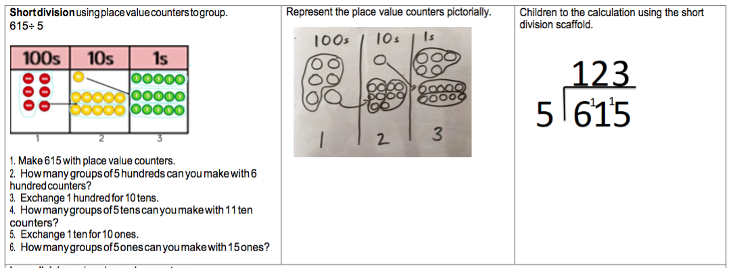
With remainders
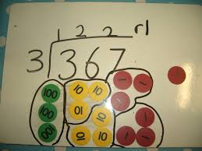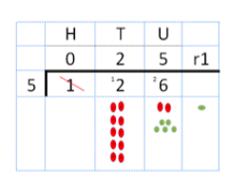
Dividing using the bar.
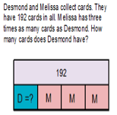

Year 5
Addition
Vocabulary
Part, whole, tens of thousands boundary,
Also see previous years
Adding numbers with more than 4 digits including decimals
Using place value charts are key to this as well as place value counters to help with the decimals.

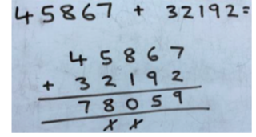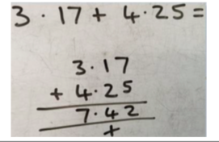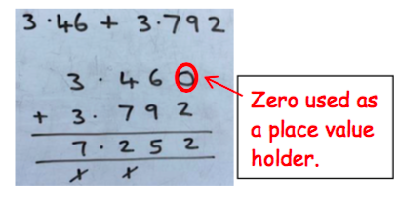
Using the bar to find missing digits.
It is important for children to use the bar in this way to encourage the use of it to aid with problem solving.
This is not a form of getting the correct answer but helping to guide children to the correct operation.
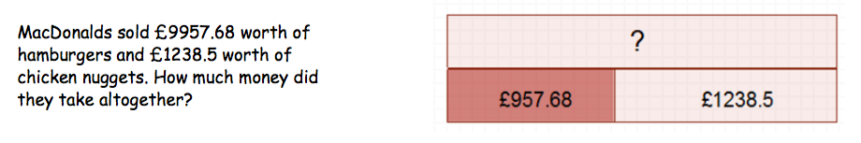
Subtraction
Vocabulary
Part, whole, tens of thousands boundary,
Also see previous years
Subtract with at least four digit numbers including two decimal places.
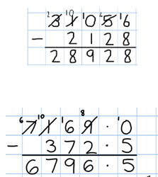
Include money, measures and decimals ensuring that children do this practically before the abstract.
Subtract with decimal values, including mixtures of integers and decimals, aligning the decimal point.
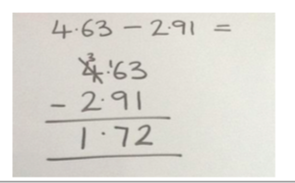

Using the bar to find missing digits.
It is important for children to use the bar in this way to encourage the use of it to aid with problem solving.
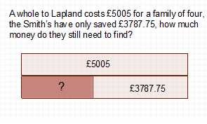
Multiplication
Vocabulary
Part, whole, cube numbers, prime numbers, square numbers, common factors, prime number, prime factors and composite numbers
Multiplying up to four digit numbers by two digits using long multiplication.
Children need to be taught to approximate first, e.g. for 72 x 38, they will use rounding: 72 x 38 is approximately 70 x 40 = 2800, and use the approximation to check the reasonableness of their answer.

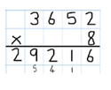
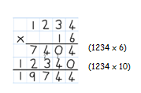
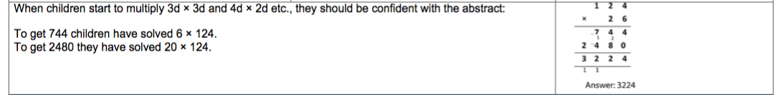
Using the bar to support multiplication.
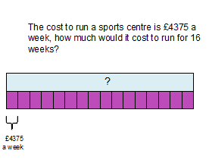
Division
Vocabulary see year 4
Part, whole, common factors, prime number, prime factors, composite numbers, short division, square number, cube number, inverse, power of
Diving with up to four digit numbers by one digit including numbers where remainders are left.

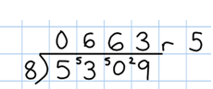
Short division with remainders: Now that pupils are introduced to examples that give rise to remainder answers, division needs to have a real life problem solving context, where pupils consider the meaning of the remainder and how to express it, ie. as a fraction, a decimal, or as a rounded number or value , depending upon the context of the problem.

Using the bar to support division problems.

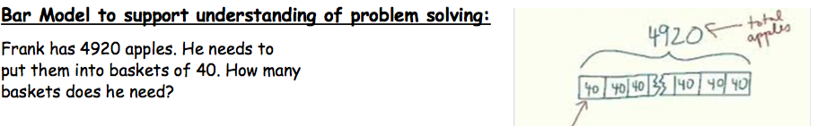

Year 6 (supporting transition into Year 7)
Addition
Vocabulary
Part, whole, See previous years
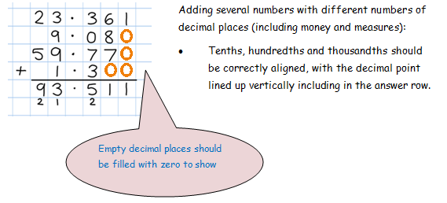
Adding several numbers with up to three decimal places.
Adding using the bar.
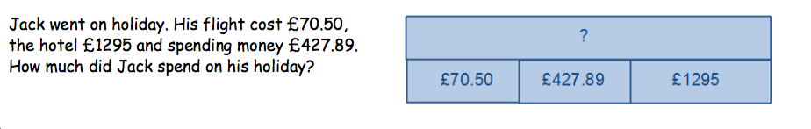
Subtraction
Vocabulary
Part, whole, See previous years
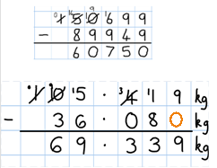
Subtracting with increasingly large and more complex numbers and decimal values.
Very important to use in a range of contexts- measures and money.
Using the bar for subtraction.
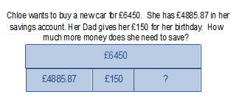
Multiplication
Vocabulary
Part, whole, See previous years and common factor
Short and long multiplication with up to two decimal places.
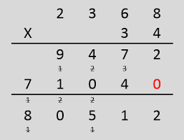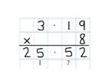

Using the bar to help with multiplication.
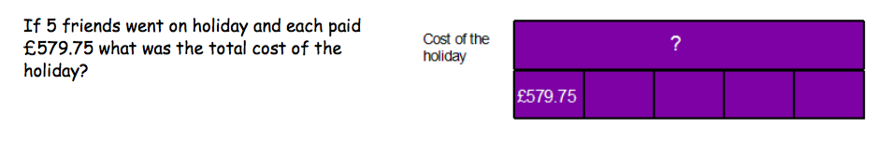
Division
Vocabulary
see years 4 and 5 Part, whole, long division
Divide at least 4 digits by both single-digit and 2-digit numbers (including decimal numbers and quantities)
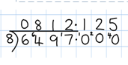
Short division with remainders: Pupils should continue to use this method, but with numbers to at least 4 digits, and understand how to express remainders as fractions, decimals, whole number remainders, or rounded numbers. Real life problem solving contexts need to be the starting point, where pupils have to consider the most appropriate way to express the remainder.
Long division this is for when dividing by two digit numbers.
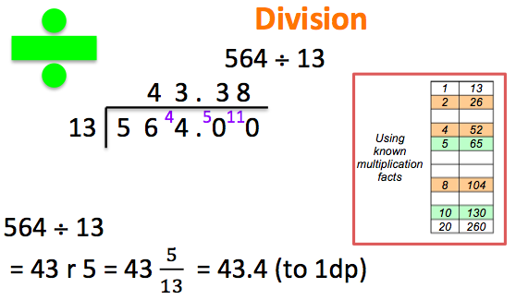
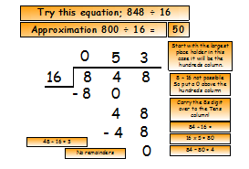
Using the bar to help divide.


